**LOOPING STATEMENTS**

1. 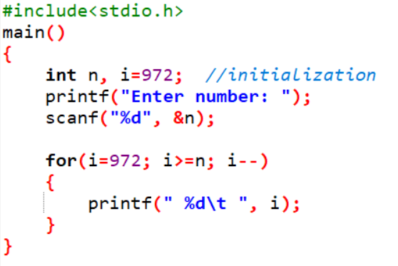**WAP to print 972 to 897 using for loop.**

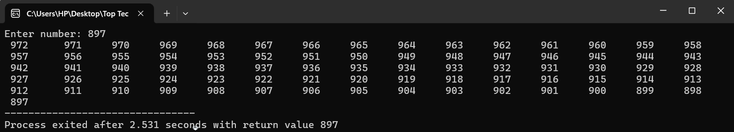**Output:**

**2. WAP to accept 5 numbers from user and display all numbers.**

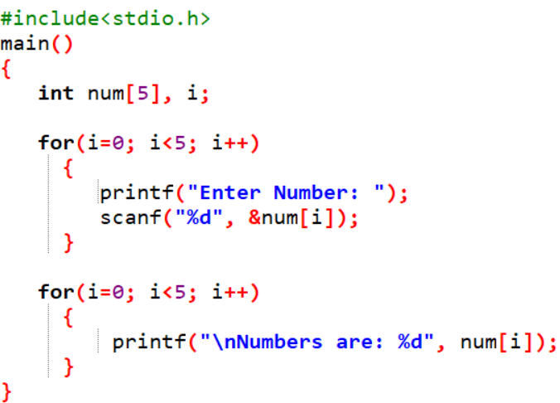

**Output:**

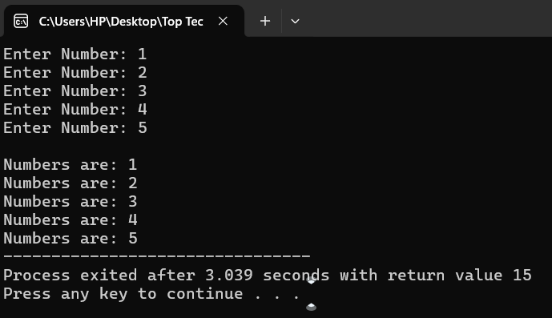

**3. WAP to take 10 no. Input from user find out below values.**

**a. How many Even numbers are there b. How many odd numbers are there**

**c. Sum of even numbers d. Sum of odd numbers**

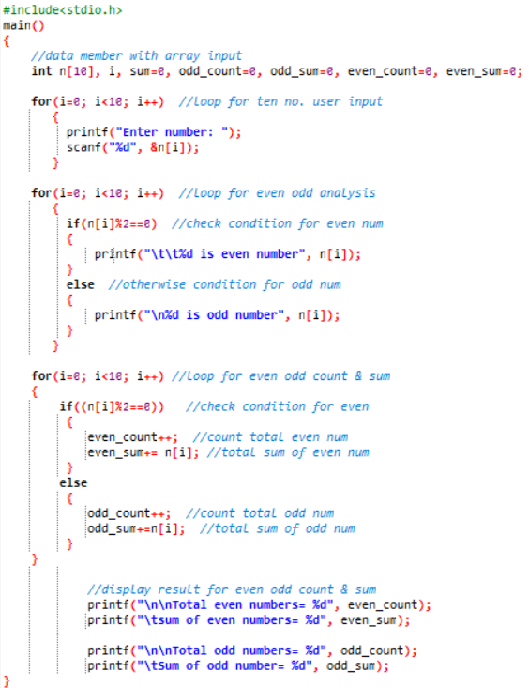

**Output:**

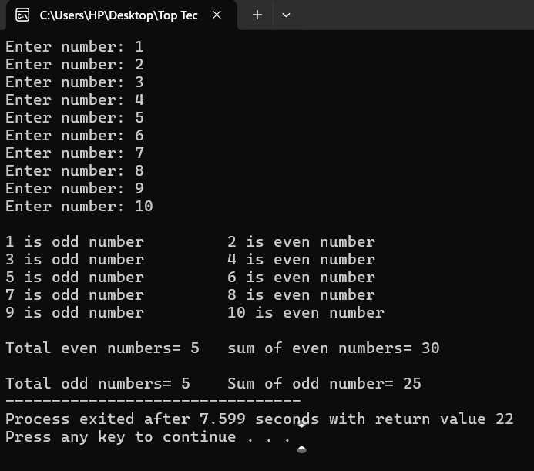

**4. WAP to print table up to given numbers.**

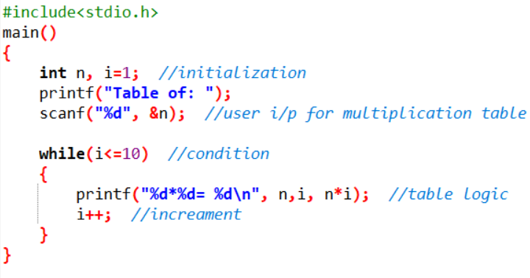

**Output:**

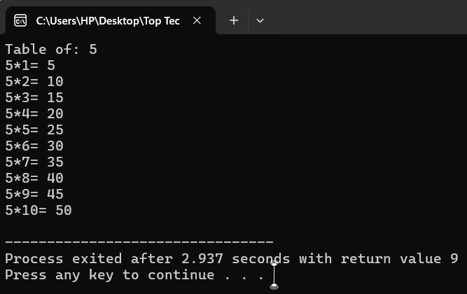

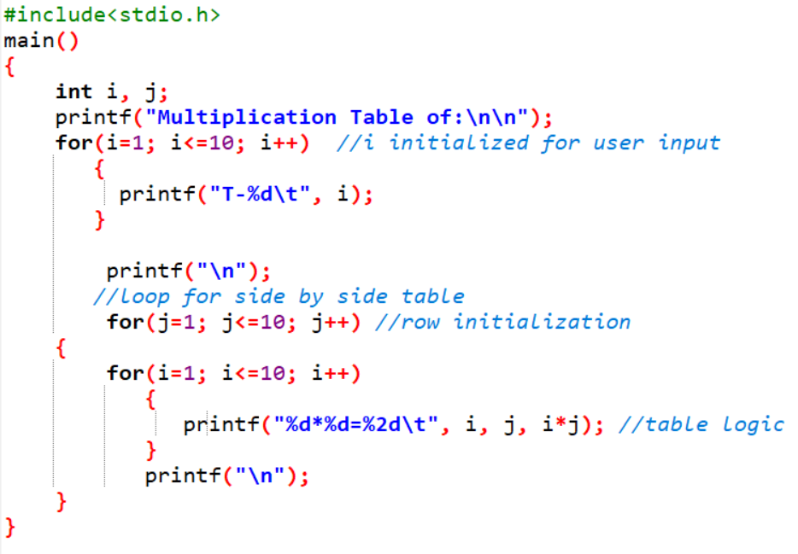**//Side by side multiplication table**

**Output:**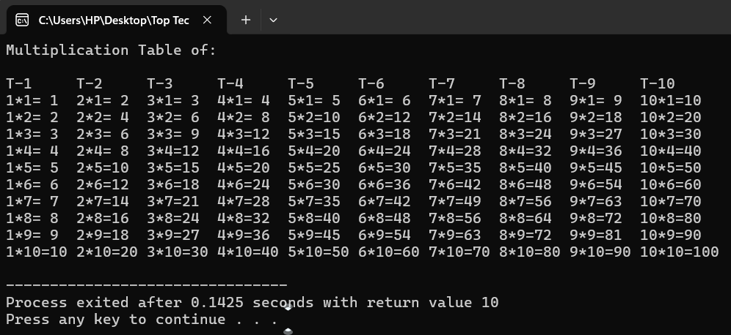

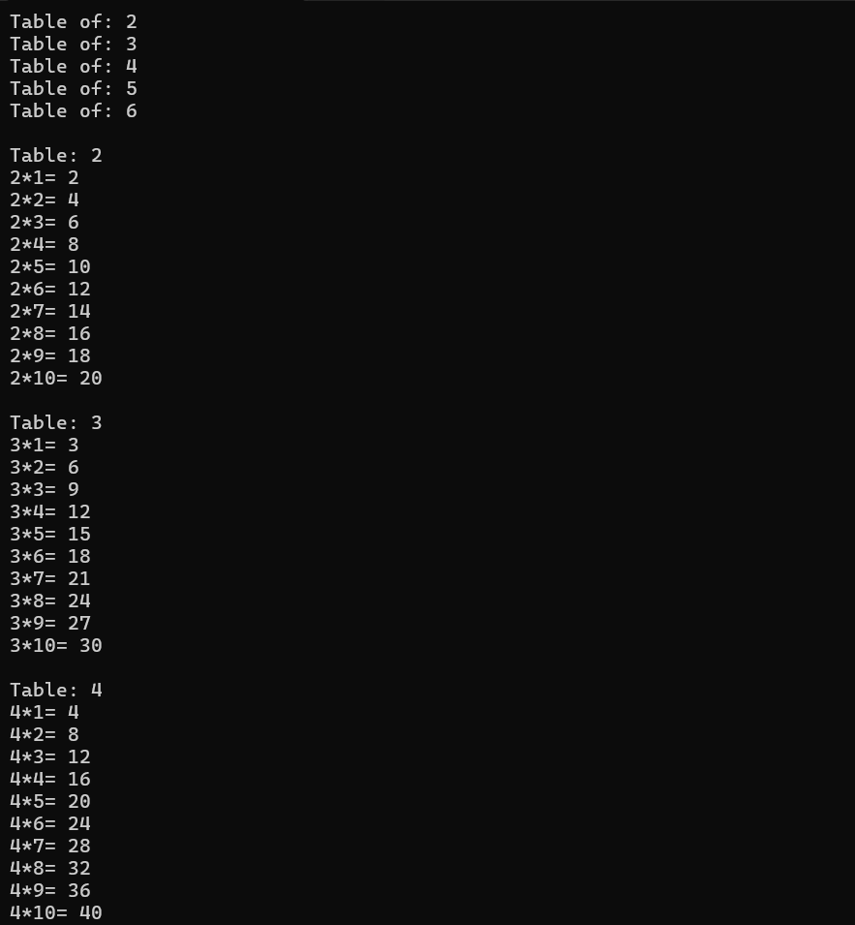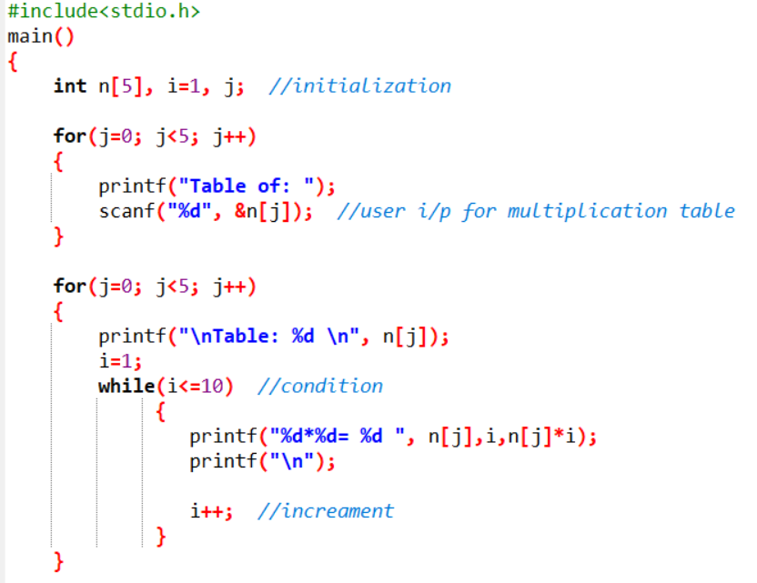**Output:**

**5. WAP to print factorial of given number.**

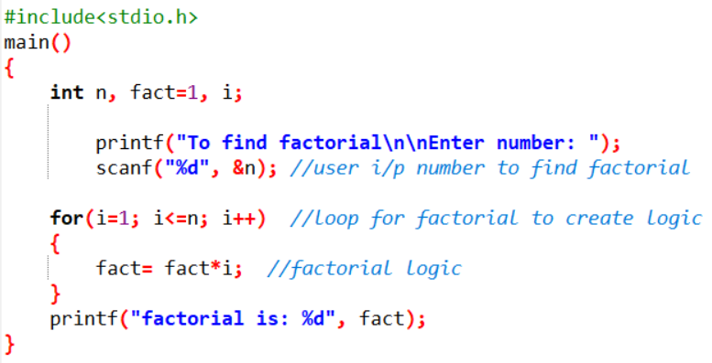

**Output:**

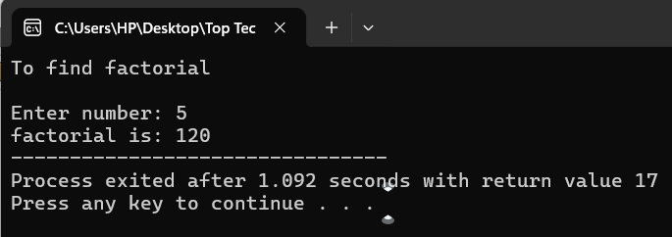

**6. WAP to print Fibonacci series up to given numbers.**

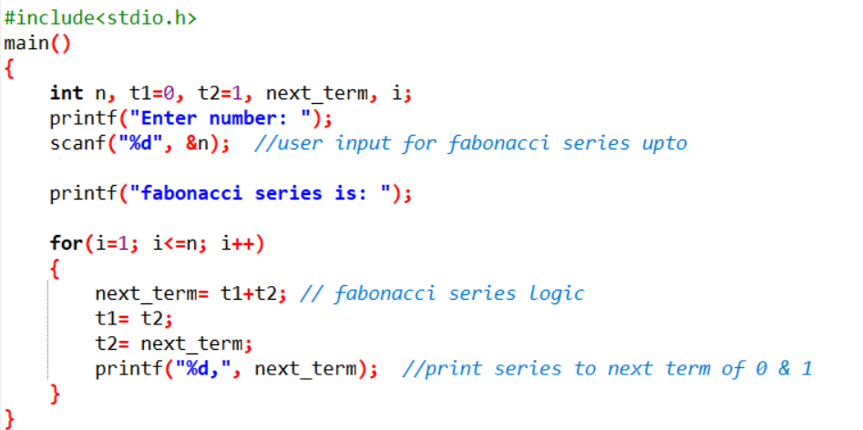

**Output:**

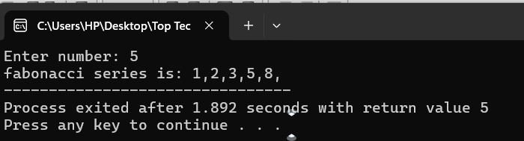

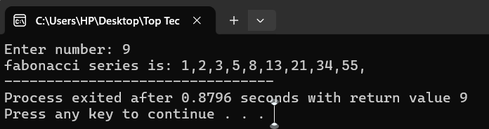

**7. WAP to print number in reverse order.**

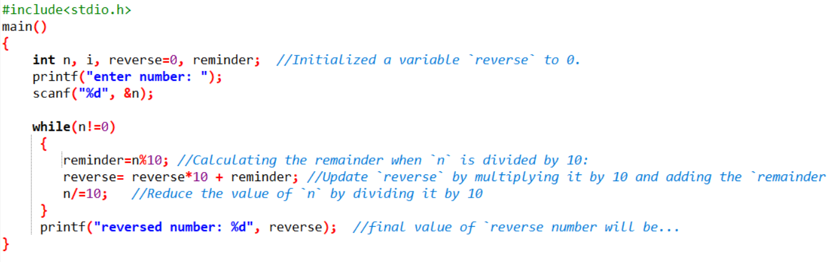**e.g.: number = 64728 ---> reverse = 82746**

**Output:**

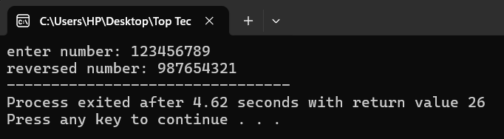

**8. Write a program to find out the max from given number**

**(E.g., No: -1562 Max number is 6).**

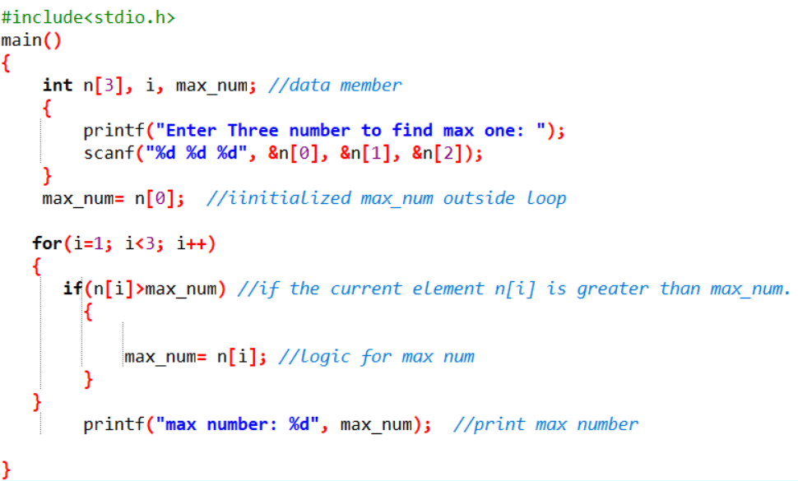

**Output:**

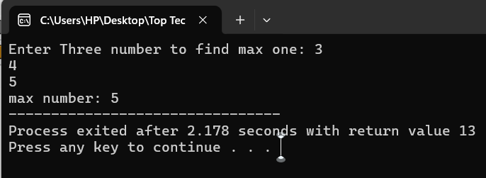

**9. Write a program make a summation of given number (E.g., 1523 Ans: -11)**

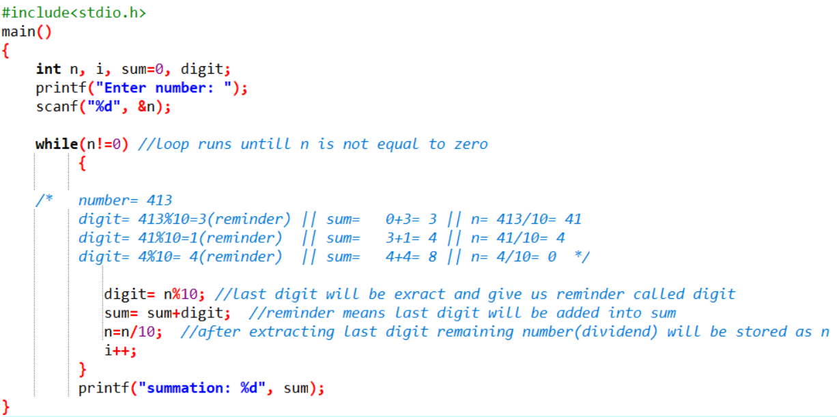

**Output:**

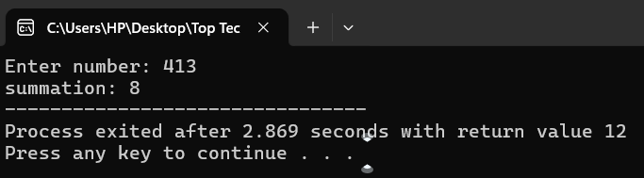

**10. Write a program you have to make a summation of first and last Digit. (E.g., 1234 Ans: -5)**

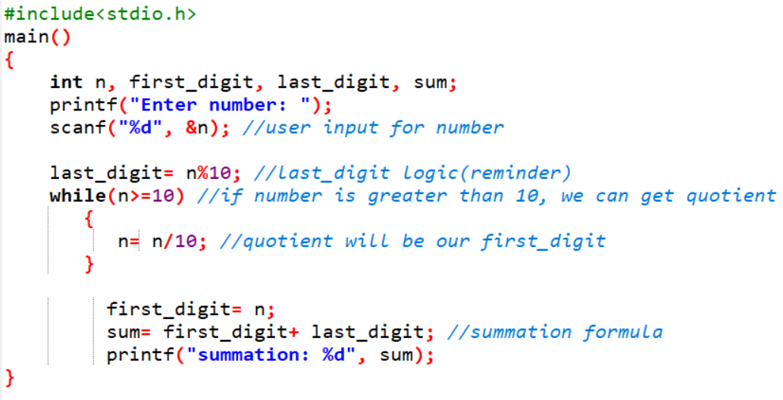

**Output:**

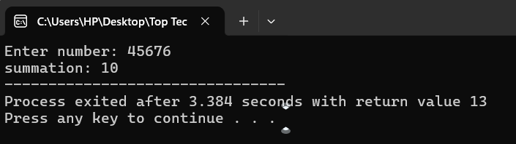

**11. Accept 5 names from user at run time.**

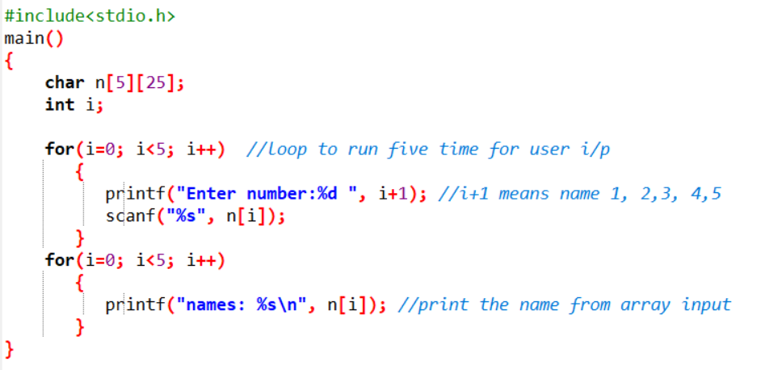

**Output:**

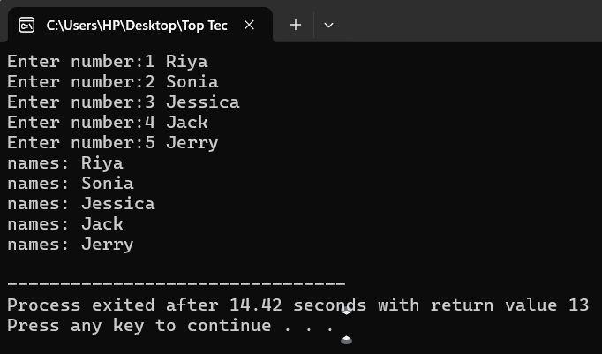

**12. Program of Armstrong Number in C Using For Loop & While Loop.**

**13. calculate the Factorial of a Given Number using while loop.**

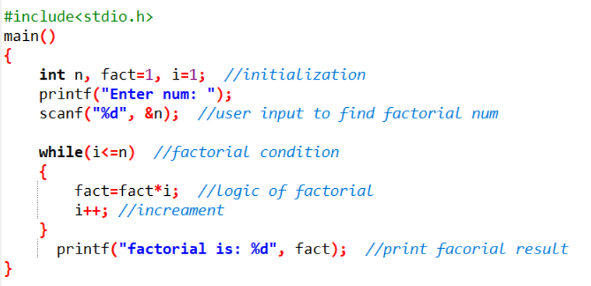

**Output:**

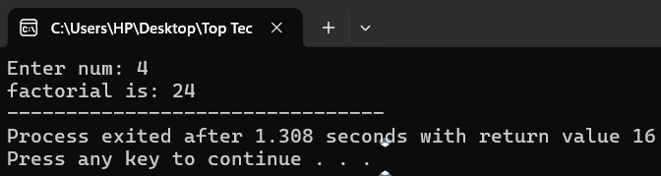

**14. Accept 5 numbers from user and find those numbers factorials.**

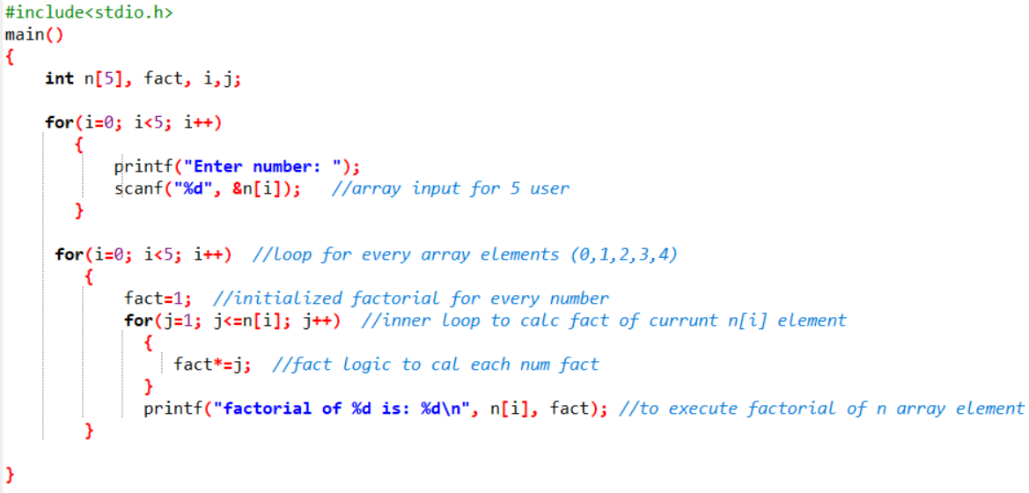

**Output:**

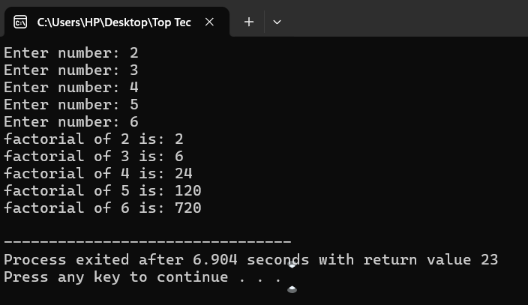

**15. Calculate sum of 10 numbers using of while loop.**

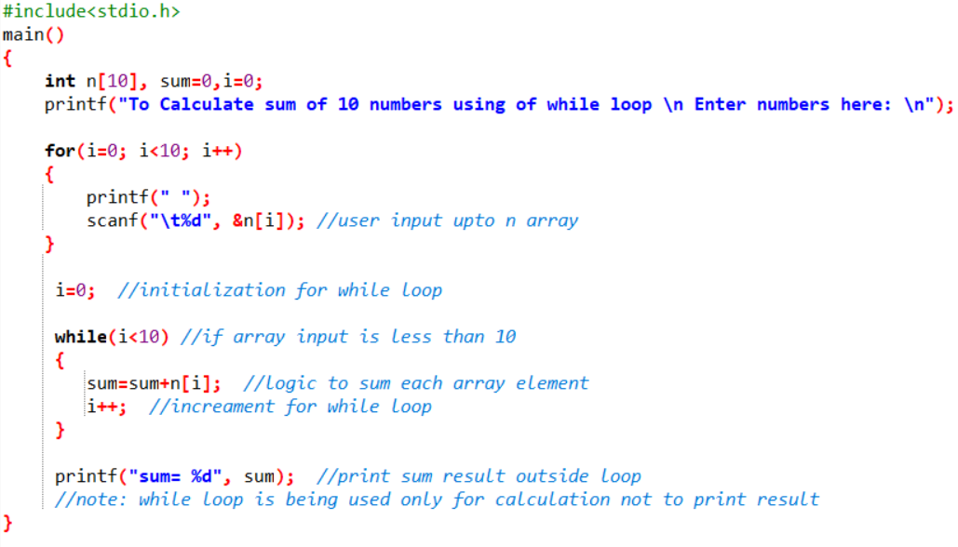

**Output:**

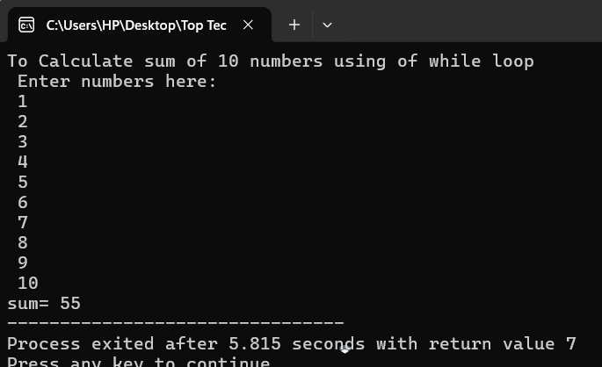

**16. Calculate the Sum of Natural Numbers Using the While Loop.**

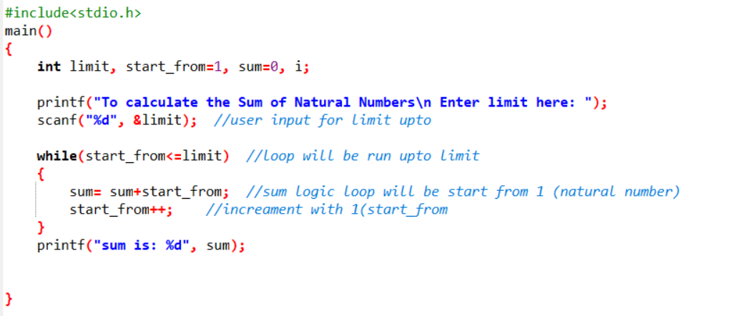

**Output:**

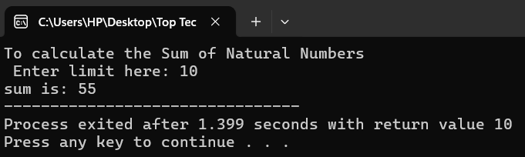

**17. Calculate 5 numbers from user and calculate number of even and odd using of while loop.**

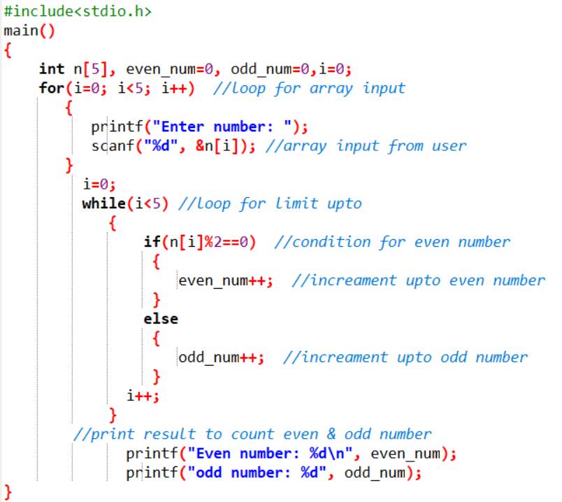**Output:**

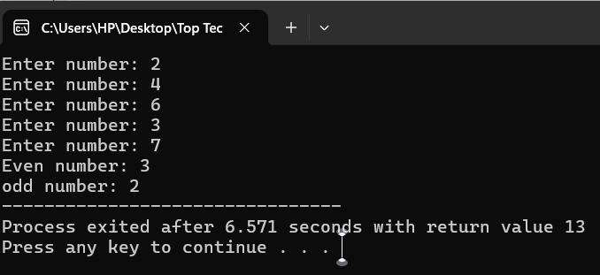

**18. Write a C Program to Print the Multiplication Table of N.**

**Ex.**

* **. 5 * 1 = 5**
* **5 * 2 = 10**
* **5 * 10 = 50**

**Output:**



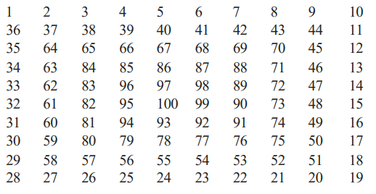**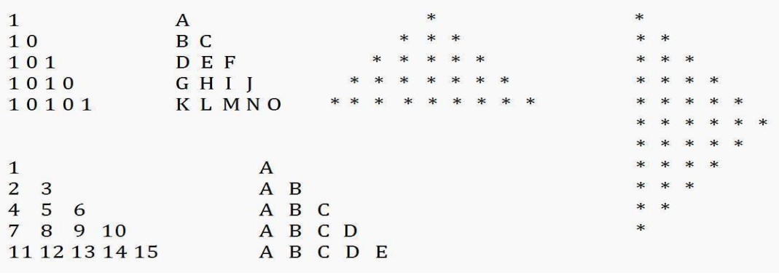19. Patterns:**

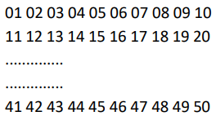**20. WAP program to print below output using for loop**.

**20.0**

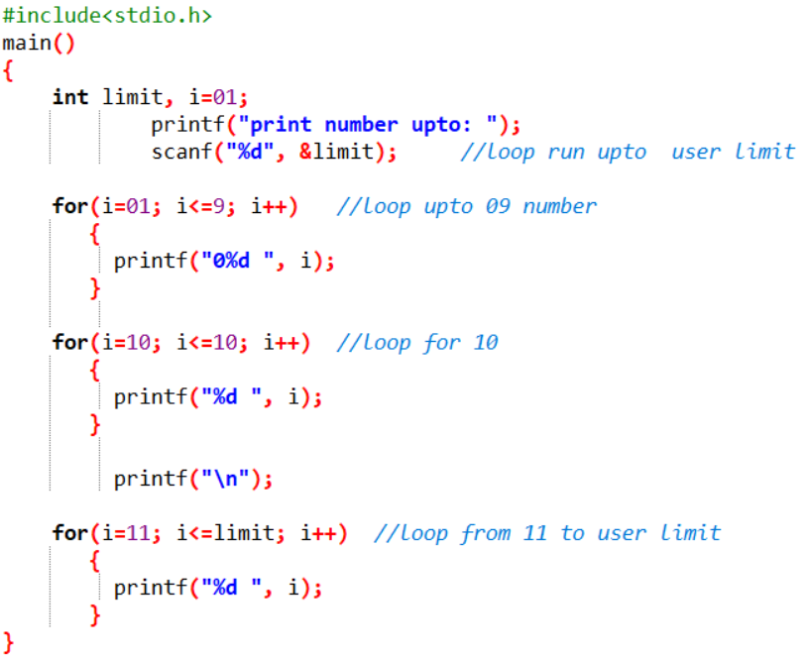

**Output:**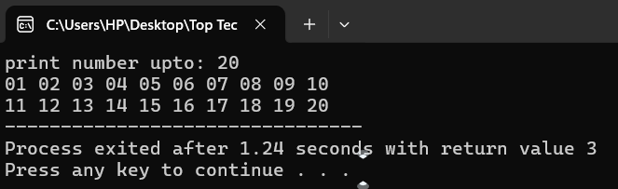

**20.1**

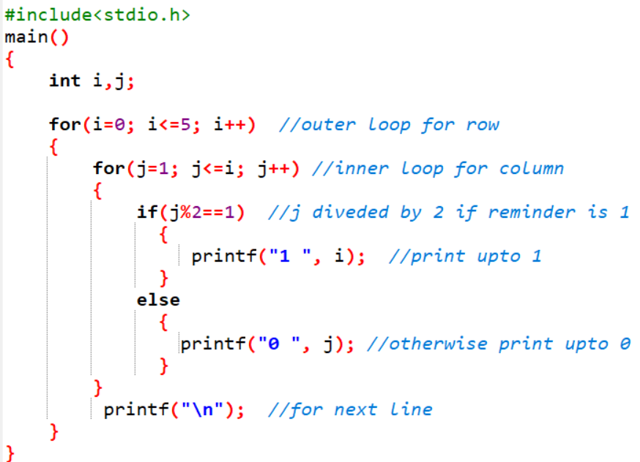

**Output:** 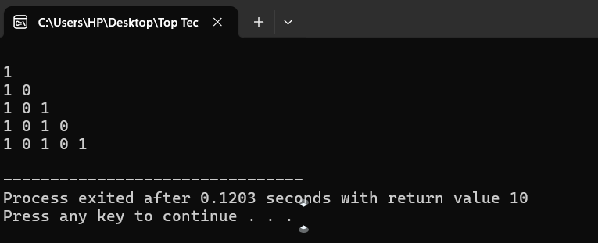

**20.2**

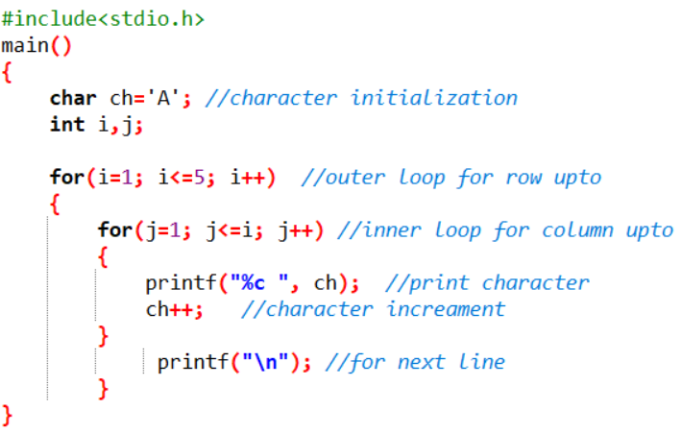

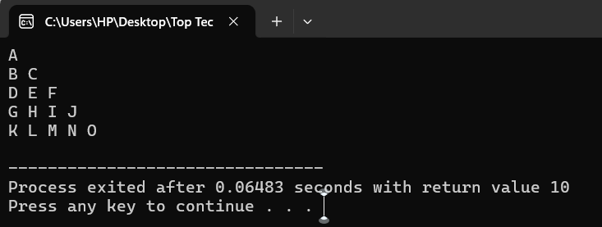**Output:**

**20.3**

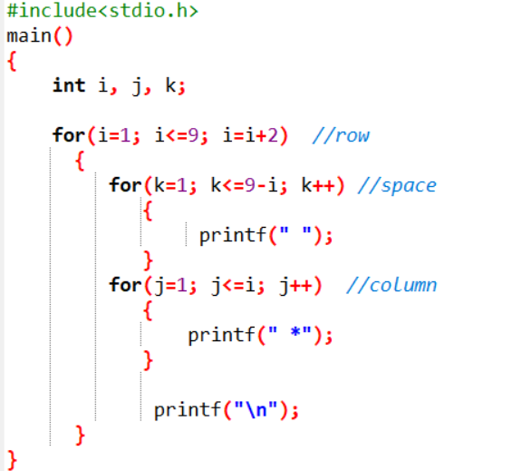

**Output:  
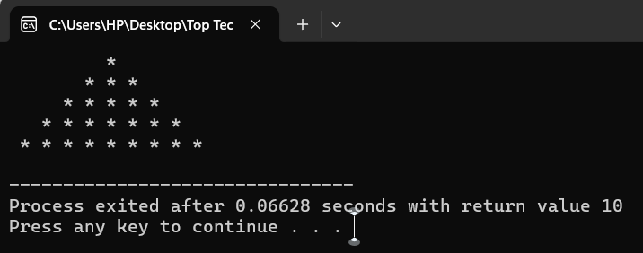**

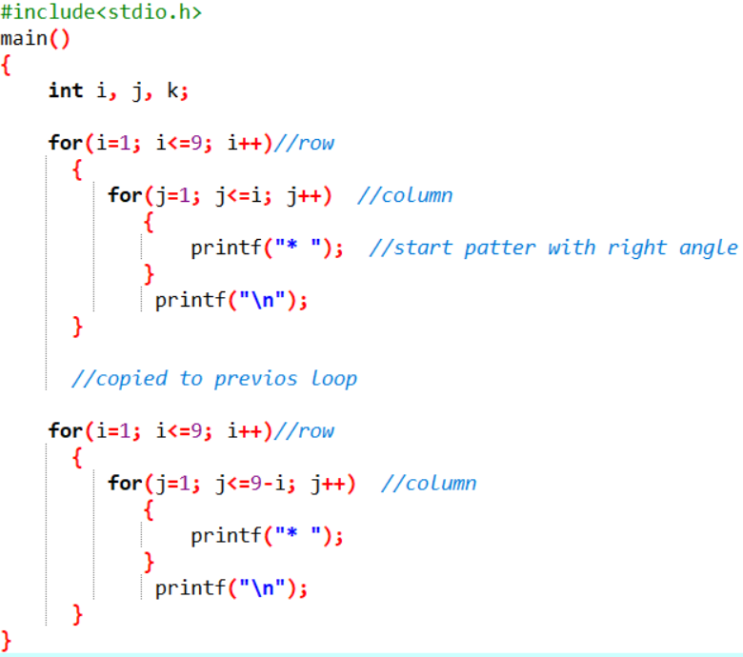**20.4**

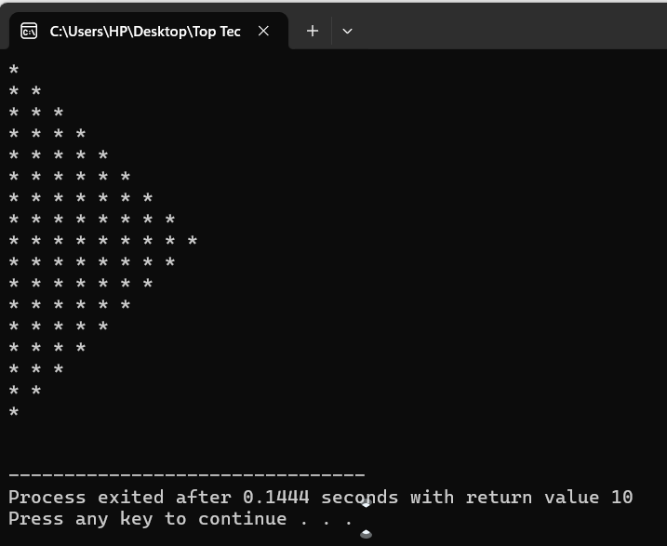**Output:20.5**

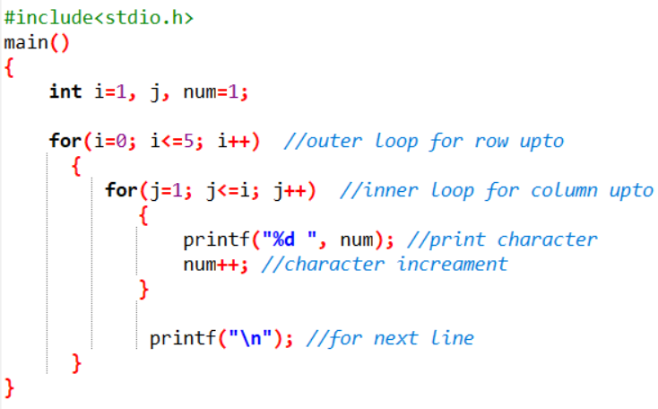

**Output:**

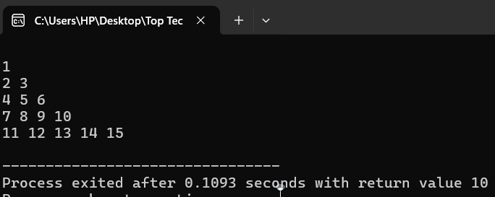

**20.6**

**22. Accept 3 numbers from user using while loop and check each numbers palindrome.**

**23. C Program to Reverse a Number Using FOR Loop.**

**Series Program:**

**24. 1 + 2 + 3 + 4 + 5 + ... + n**

**25. (1*1) + (2*2) + (3*3) + (4*4) + (5*5) + ... + (n*n)**

**26. (1) + (1+2) + (1+2+3) + (1+2+3+4) + ... + (1+2+3+4+...+n)**

**27. 1/2 - 2/3 + 3/4 - 4/5 + 5/6...........n**

**28. 1 2 3 6 9 18 27 54...**